ASSIGNMENT 3
1.Write a program to print pyramid pattern.
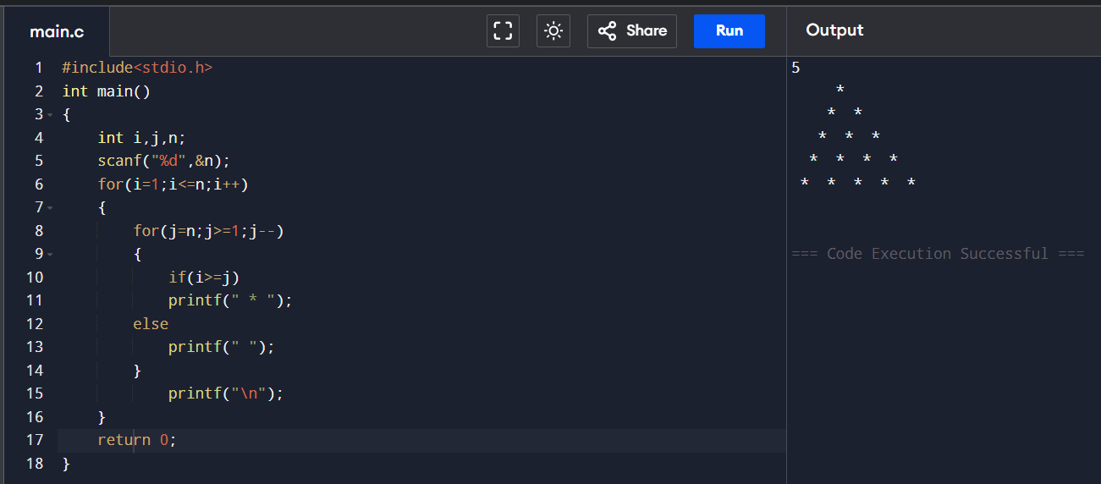
2. Write a program to print right triangle pattern.
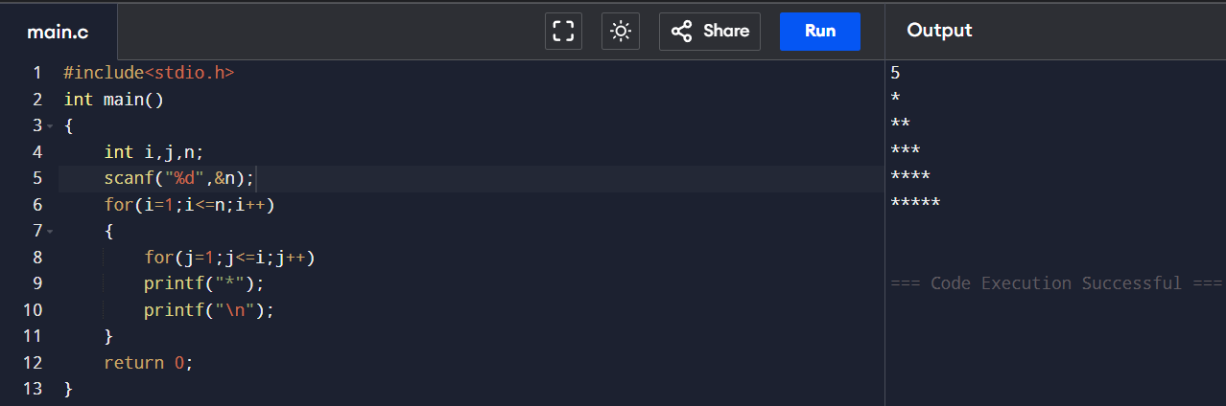
3. Write a program to print inverted right triangle pattern.
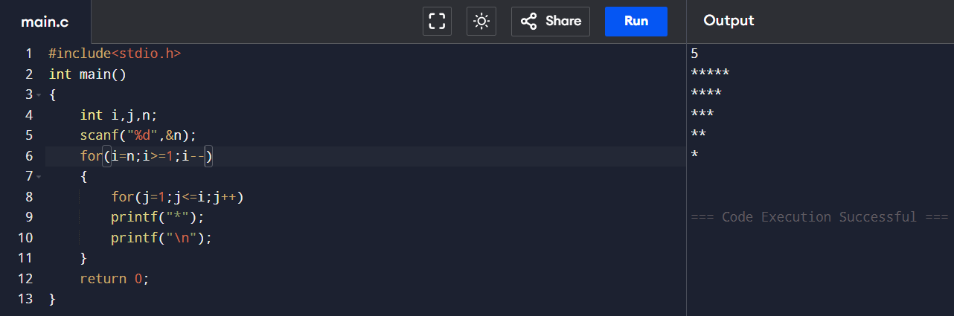

4. Write a program to print square pattern.
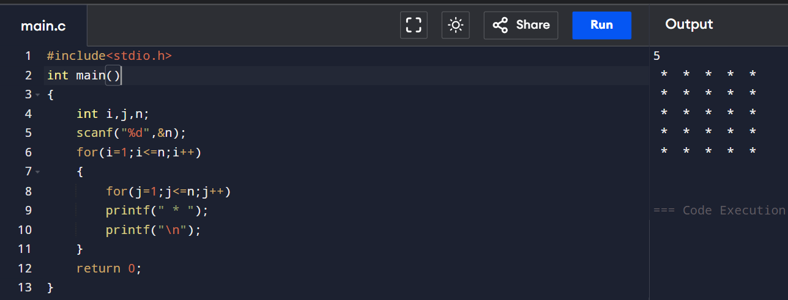

5. Write a program to print floyid’s triangle.
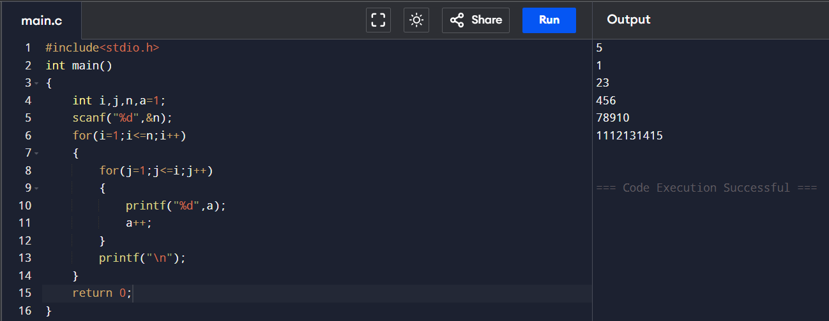
6. Write a program to print hollow square pattern.
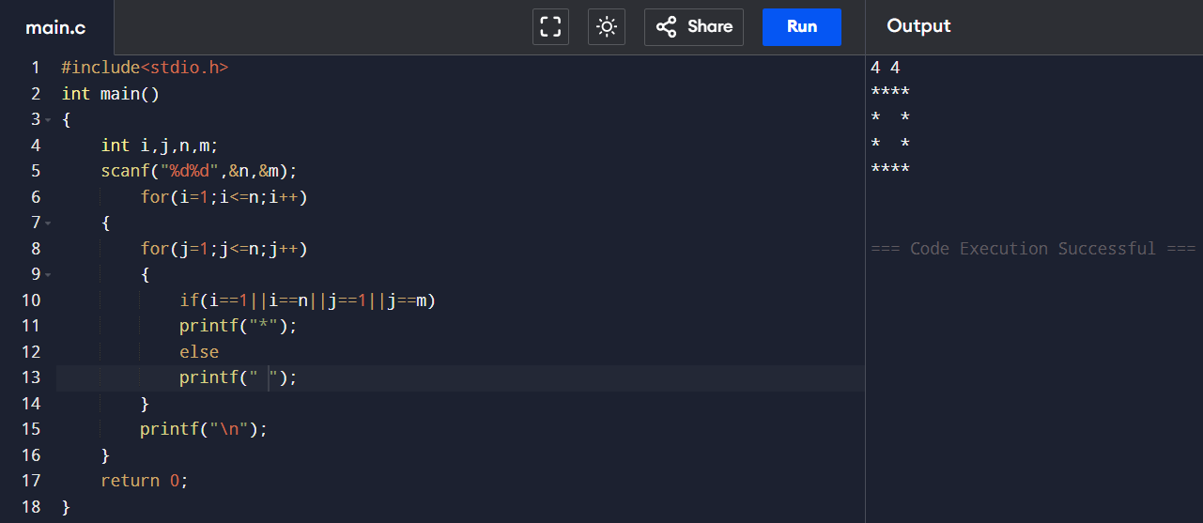

7.Write a program to print number pattern.
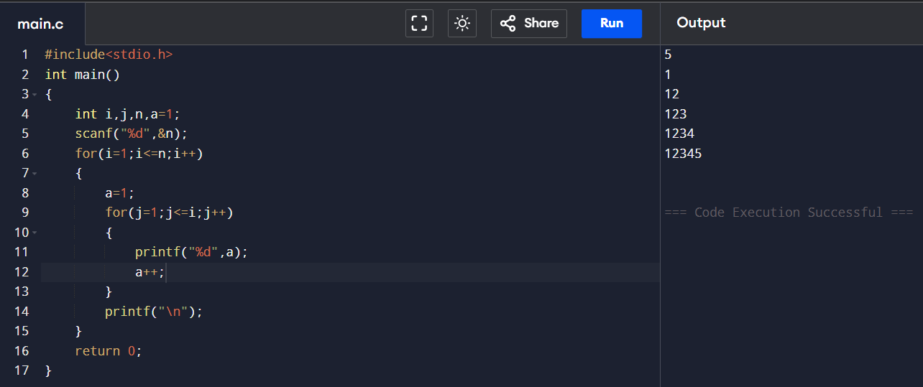
8. Write a program to print pascal triangle pattern.
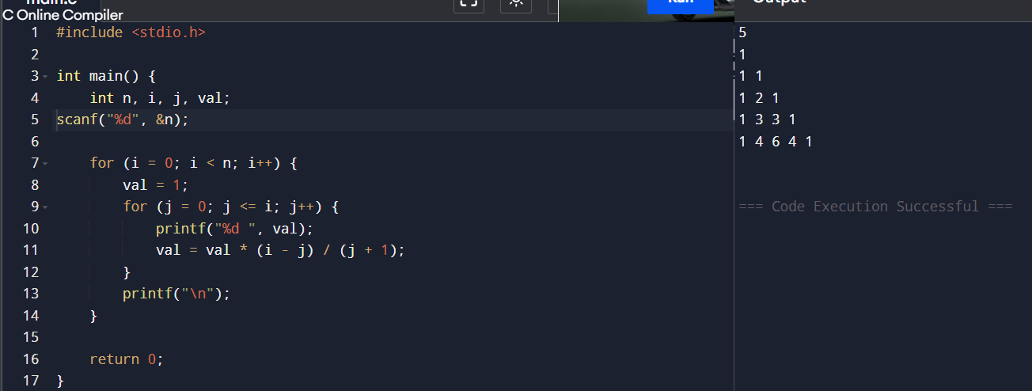
9. Write a program to print Dimond pattern.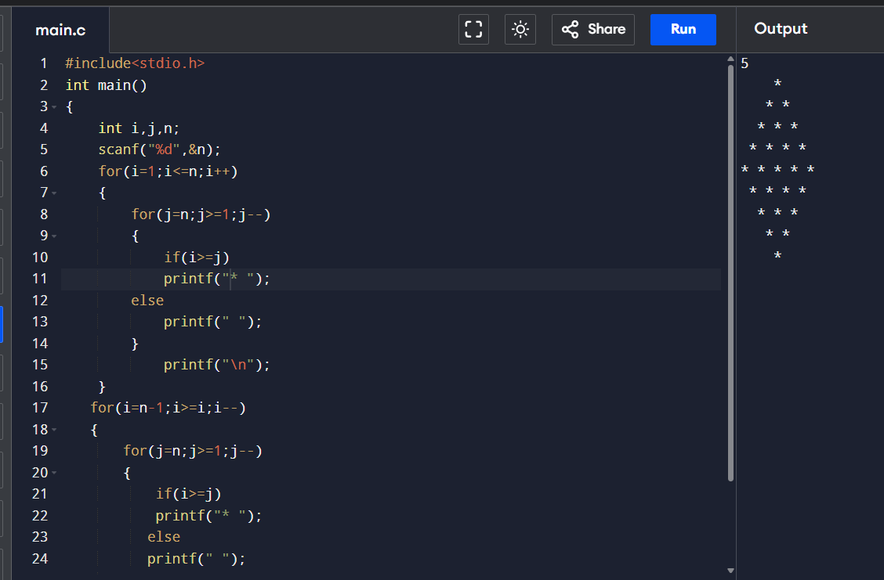
10. Write a program to print hollow Dimond pattern.
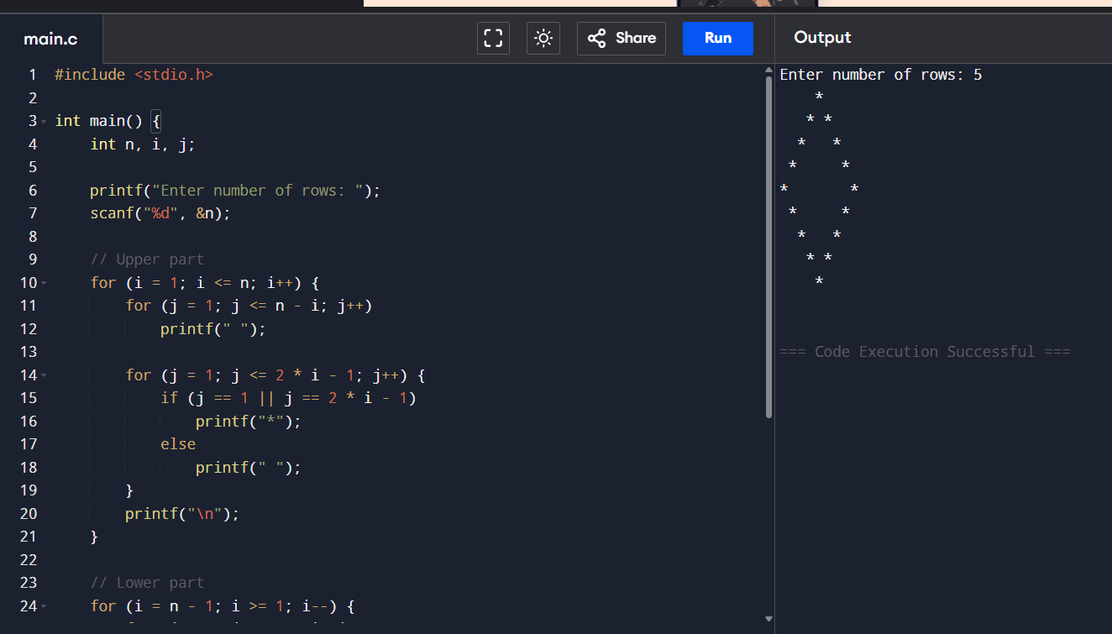

11. Write a program to print the inverted pyramid pattern.
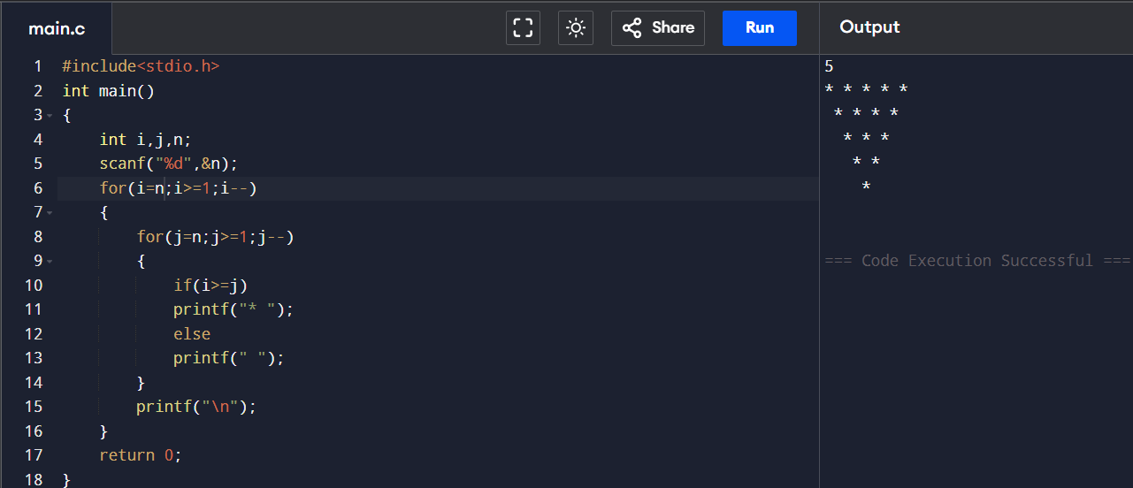

12. Write a program to calculate the nCr for given n and r numbers. (use Binomial coefficient formula)
